11thSeptember2017

Invitation

To:Korea Alpine federation
In order to share the advanced mountain rescue technology and successful experience both domestic and abroad, to strengthen technical exchanges and cooperation among international mountain rescue organizations, and to promote the development of mountain rescue together,Chinese Mountaineering Association will organize International Mountain Rescue Exchanges 2017, to be held in Anlong County, Guizhou Province, China from 27th to 30th October, 2017.
On behalf of Chinese Mountaineering Association, we have the pleasure to invite 4 representatives of your Association to attendthis event, and share the special report of your Association’s mountain rescue development situation and give us the practical operationdemonstration of the advanced mountain rescue technology.
The costs will be borne by us.
We look forward to see you in this event!
Should you need any further assistance, please contact Mrs. Zhu Xueyan from Chinese Mountaineering Association at 69741337@qq.com or +8610 67123796

Yours sincerely,
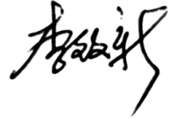

Li Zhixin
President
Chinese Mountaineering Association
Add: No.9 Tiyuguan Road, Dongcheng District, Beijing, China

